**Operating System**

**Basic Shell Commands**

**Q # 1:**

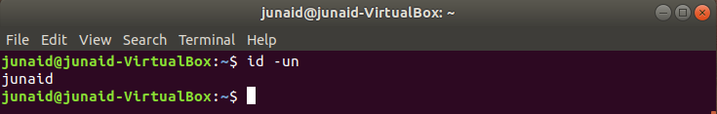

**Q # 2:**

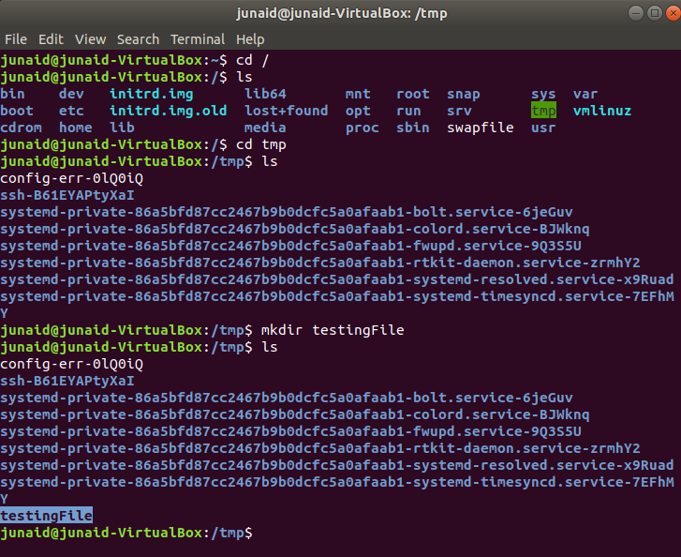

**Q # 3:**



**Q # 4:**

**rm** command is used to remove files/folder. On the other hand, **mkdir** command is used to remove empty directory only. It won’t work for non-empty directory. If we want to remove all directories and sub-directories, we have to use **rm -r**.

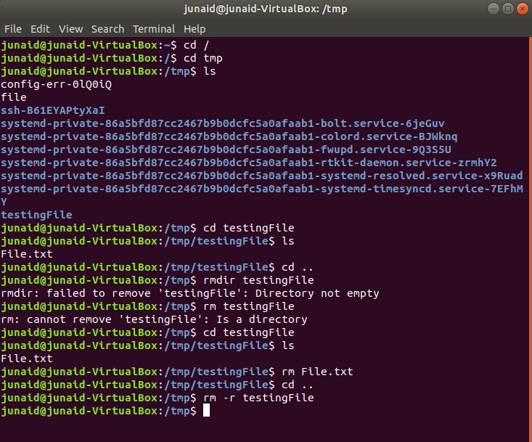

**Q # 5:**

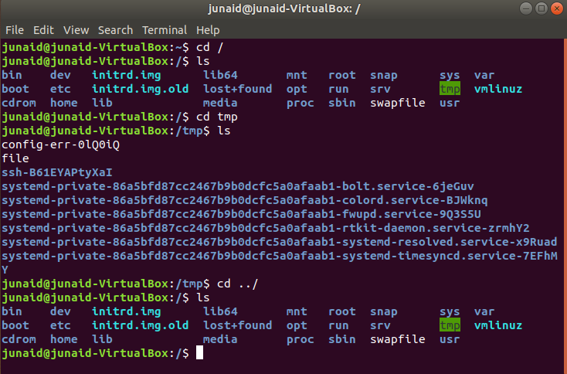

**Q # 6:**

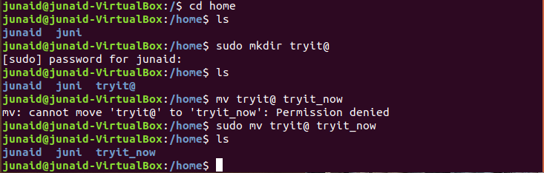

**Q # 7:**

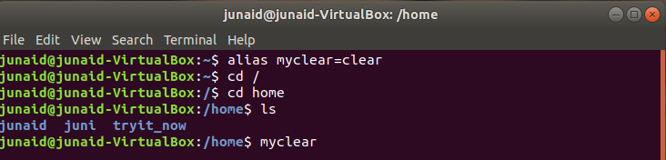

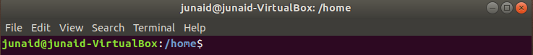

**Q # 8: (a)**

First cls became the alias of clear. By executing cls the output will be same as clear. When it became the alias of ls, cls overwritted the previous alias with ls and by executing cls now, output will be same as ls.

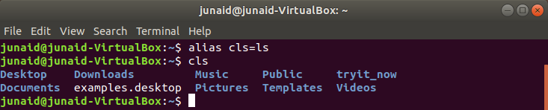

**(b):**

**Mkdir d1** will make new directory.

**Cd d1** will bring us inside d1 directory.

**Touch f 1 f 2** will make two sub files in d1.

**Touch f 1** will again overwrite previously build f 1.

**Cd** will take us outside.

**Mkdir d1** will give us error message because file already exists.

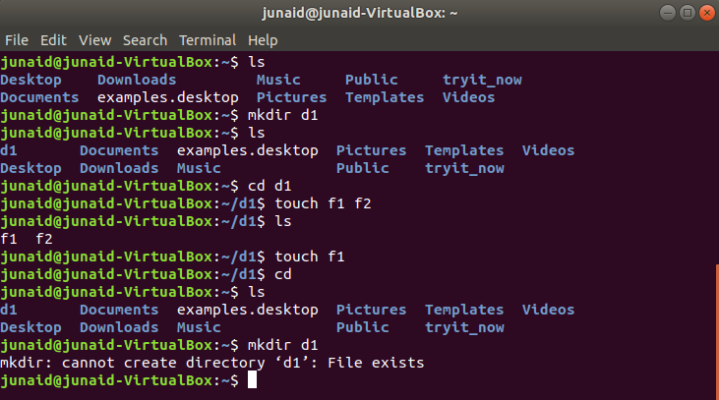

**Questions**

**Q # 1:**

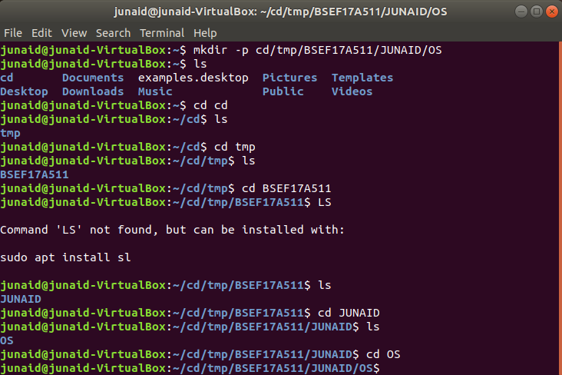

**Q # 2:**

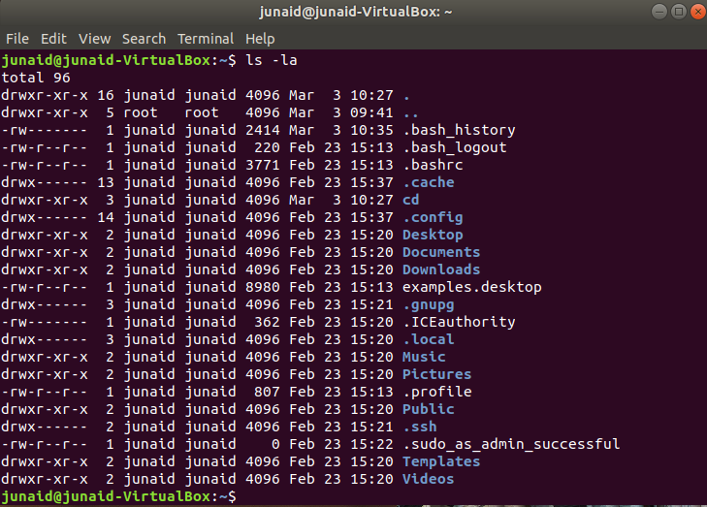

**Q # 3:**

**Way 1:** I can use rm -r cd to remove all contents of cd at once.  
**Way 2:** I can use rm -rf cd to forcefully remove all contents of cd at once.

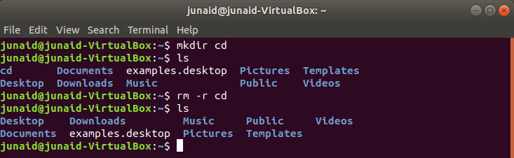

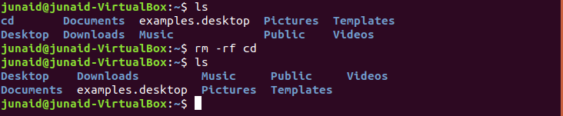

**Q # 4:**

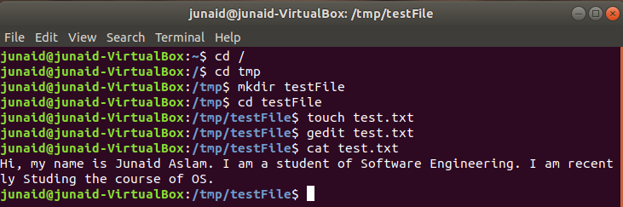

**Q # 5:**

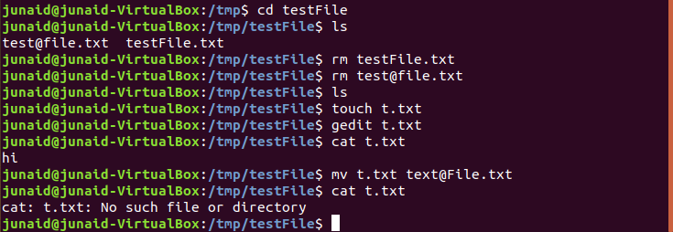

**Q # 6:**



**Q # 7:**

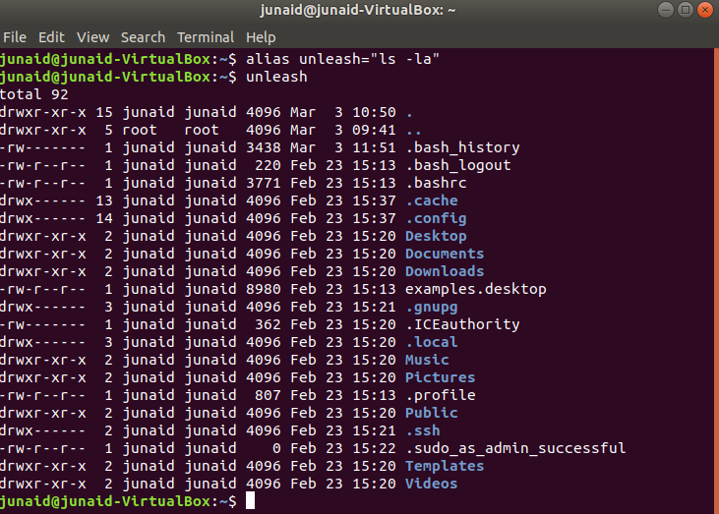

**Q # 8:**

**“man ls”** is a command that is used to display complete details of command on shell.

**Q # 9:**

We have to write just **“type”** before type to find out whether it is internal command or not.

**Q # 10:**

**Way 1:** rm -r to remove all contents of directory at once.  
**Way 2:** rm -rf to forcefully remove all contents of directory at once.

**Absolute/Relative Path**

**Q # 1:**

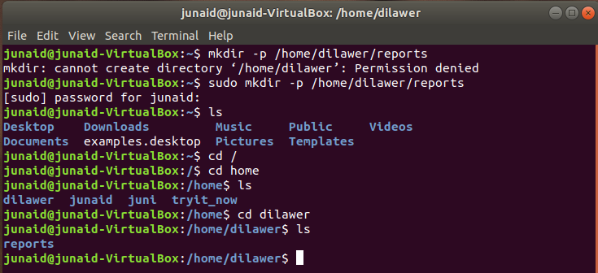

**Q # 2:**

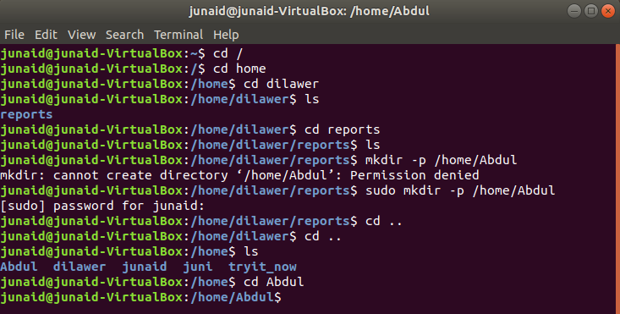

**Q # 3:**

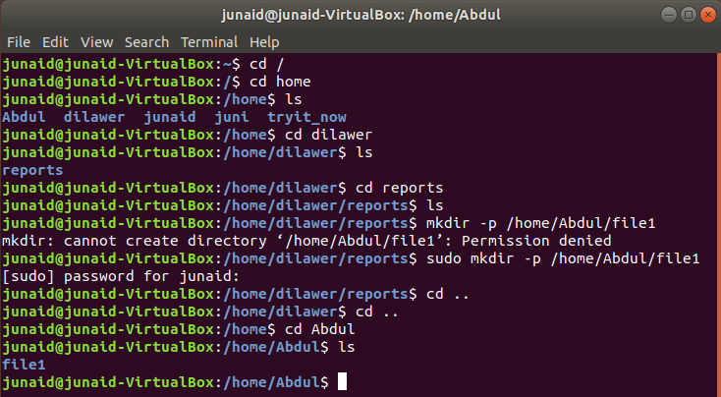

**Q # 4:**

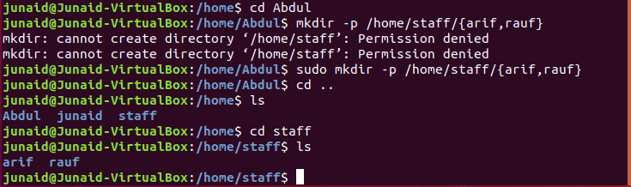

**Q # 5:**

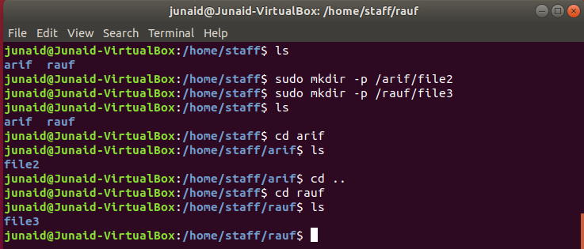

**Q # 6:**

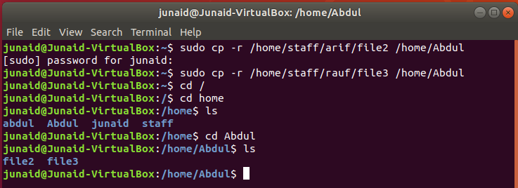

**Q # 7:**

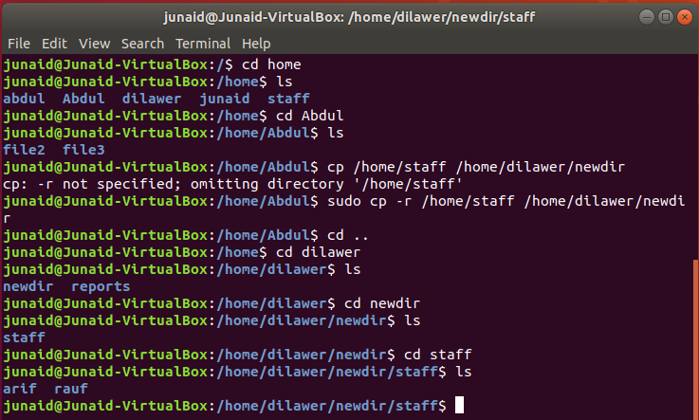

**Q # 8:**

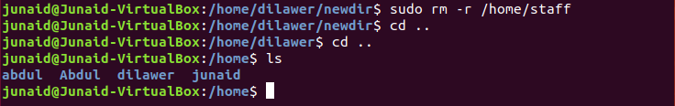

**Q # 9:**

